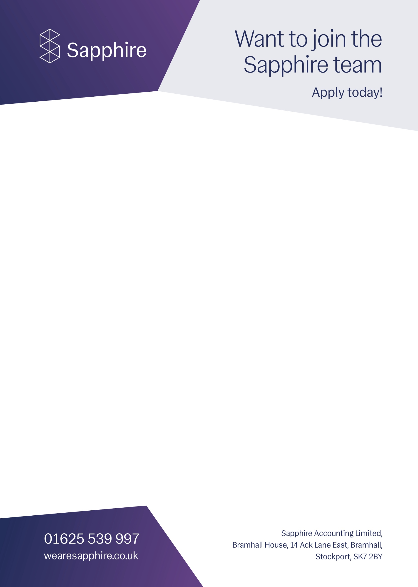  Role title | Internal Finance Executive
Hour of work | Monday - Friday 9:00am - 5:30pm
Salary | £25,000 - £27,000
The Person | - ‘Above and beyond’ attitude  - Driven  - Keen to learn & develop  - Takes responsibility  - Team player  - Contributes with ideas  - Thrives in a fast-paced work environment  - Effective communicator  - Be detail oriented with a pragmatic approach to problem solving  - Confident, highly self-motivated and comfortable with challenging others and being challenged  - Keen to learn  - Be ambitious and keen to embrace new challenges  - Have a minimum B grade in GCSE Mathematics  - Be AAT part qualified, an accounting & finance graduate or equivalent  - Have detailed knowledge of the SAGE accounts or a similar system
Why Sapphire? | - Employee-owned company  - A minimum of 34 days holiday (rising with service), including your birthday off  - Monthly team get-togethers  - A range of company incentive targets  - Incentive trips -previously Las Vegas, Barcelona, New York and more  - A brand new office with a games room, bar and flexible working space  - Fresh fruit and smoothies  - Access to an employee healthcare membership

Main areas of responsibility
Vacancy description | This is an exciting role in an Employee Owned Payroll and Accountancy business based in Bramhall which plans to grow its client base significantly over the next 12 months.  The individual will coordinate and execute financial transactions and activities, such as bill payments and invoicing. Assist in the audit process by providing information and data as requested. Complete administrative tasks, such as monitoring transactions and liaising with the sales department. Monitor budgets, forecasts and future cash flows.
Principle Responsibilities | To deliver a structured accounting service for the senior management team including the following:  - Assisting with the preparation of the weekly group Profit and Loss statement  - Weekly bookkeeping from group companies using Sage 50 software including adjustments  - Recording of company credit card transactions and associated receipt  - Issuing customer invoices on an ad hoc basis  - Assisting in collating information for regular Direct Debit collections  - Monitoring aged debt within the group and reporting to the necessary managers for action
Recruitment process | There will be a 2 hour face-to-face interview process, preceded by a 15 minute Teams interview:  - Numeracy exercise (15 mins)  - Q&A (45 mins)  A personality profiling questionnaire may be conducted on successful candidates  at the end of the Q&A’s
